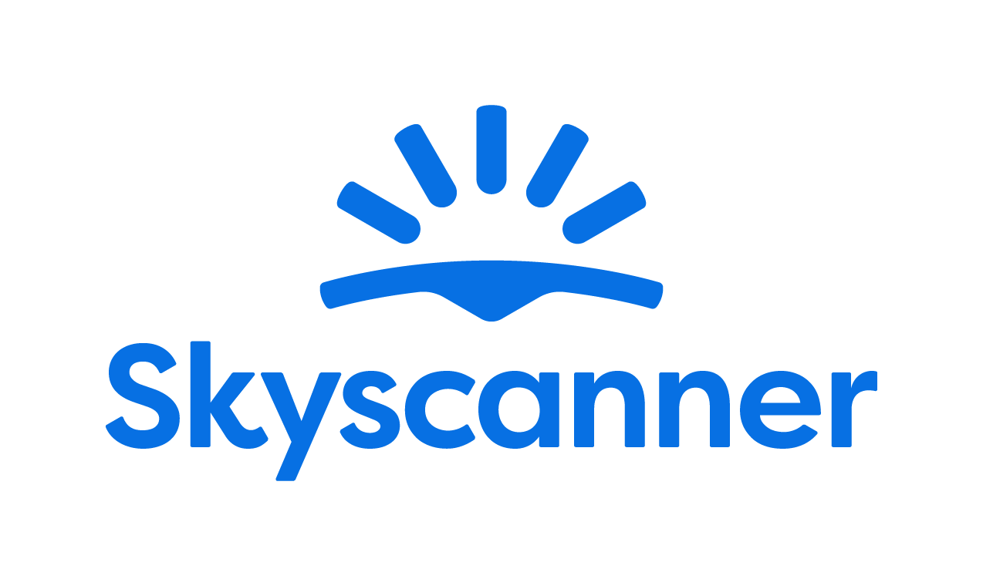

Localisation Style Guide

How to write and translate for Skyscanner in Hebrew

1. Our Tone of Voice 4
1.1 Playful 4
1.2 Geeky 5
1.3 Helpful 6
1.4 Using the tone of voice in localisation 9
2. General writing and translation guidelines 10
2.1 URL requirements 10
2.2 Placeholders, variables and tags 10
2.3 Inclusive language 12
3. Language-specific translation guidelines
13
3.1. Punctuation and spacing 13
3.2. Formats 14
3.2.1. Dates, time and numbers 14
3.2.2. Currency 15
3.2.3. Units of measurement 15
3.3. Emphasis and intensifiers 15
3.4. References 16
3.5. The use of Anglicisms 16
3.6. Abbreviations and acronyms 16
3.7. Addressing our users: Formality, T/V policy, Inclusivity Plural vs Singular 17
3.8. CTAs and active voice 18
3.9. Imperatives 18
3.10. Linguistic sequence 19
3.10.1. Transliteration 19
3.10.2. Geo-terms 20
3.10.3. Airport names 20
4. Cultural sensitivity 21
4.1. Emojis and symbols 21
4.2. Imagery 21
5. Translation guidelines per content type 21
5.1. User Interface (UI) 21
5.2. Marketing 22
5.3. SEO 22
5.4. Google Ads 23
5.5. App store 23
5.6. Editorial and blog posts 24
5.7. Emails and push notifications 24
5.8. Legal, Policies, Terms and Conditions 24
6. Other Skyscanner-specific guidelines 25
6.1. Use of Skyscanner brand 25
6.2. Feature naming 25
6.3. The use of “Best” 26
6.4. The use of “Discount” 27
6.5. Translating sustainability-related content 27
6.6. Accessibility guidelines 28
7. Useful resources and links 28

Our Tone of Voice

Skyscanner sounds like a Geeky Travel Pal. This means that:
- Our tone is playful
- Our energy is geeky
- Our message is helpful
Our brand promise is to be a helpful, honest travel ally. Our tone of voice should always support this:
- We give clear, useful information so travellers feel savvy.
- We are fair and transparent, so travellers feel confident and secure.
- We lead with empathy, so travellers feel valued and understood.
When localising, keep the same personality, but adapt expressions so they feel natural in your language and culture.

1.1 Playful
Our tone is playful. We write with a light, natural energy. Playfulness helps us feel human and builds trust – but it must never reduce clarity.
What playful means for us:
- A conversational tone, as if talking to a friend.
- A rhythm that feels lively, not flat or robotic.
- Turning travel frustrations into simple tips and “travel hacks”.
Example:
Instead of: Compare multiple airlines simultaneously and eliminate the need for multiple browser tabs.
כדאי להשוות בין מספר חברות תעופה בו זמנית ולהיפטר מלשוניות מרובות בדפדפן.
We’d say:
Do | Don’t
Finally, a way to compare flights without opening so many tabs that your computer breaks a sweat.  סוף סוף יש דרך קלה להשוות טיסות – אפשר פשוט לסגור את כל הלשוניות האחרות ולתת לנו לעשות את העבודה בשבילכם. | Warning: Our flight comparison tool finds deals so fast you'll think your browser is wearing a jetpack! Fasten your seatbelts for savings!  אזהרה: הכלי שלנו להשוואת טיסות מוצא דילים כל כך מהר שתחשבו שהדפדפן שלכם לובש תרמיל ריחוף! הדקו את החגורות והתכוננו לחסוך!

Use these tools when they feel natural and keep meaning clear (and when they work in your language):
- Rhyme – e.g. “Low fares, fewer cares.”
- Alliteration – e.g. “Brilliant breaks on a budget.”
- Metaphors – e.g. “Low prices can be like foxes - vanishing right after you've spotted them.”
- More vivid adjectives – e.g. “Glistening” instead of “Bright”
Use these tools sparingly and only if they localise well:
- Puns (Nothing too obvious or too corny).
- Long compound adjectives – e.g. “pinch-me-this-is-real views”.
- Elongated vowels – e.g. “Beeeautiful”.
- Interjections – e.g. “Oh. Ah. Phew. Oof.”
Always choose clarity over wordplay. If a device is hard to adapt or sounds unnatural in your language, do not use it.
Avoid
- “Fake-smart” corporate or management speak.
- Overly formal or stiff phrases.
- Trying too hard to be “LOL-funny”.
The English examples above are intentionally left untranslated, as they serve to illustrate the type of linguistic device being referenced rather than provide phrases to be reused.

1.2 Geeky
Our energy is geeky: we love data, details and patterns – and we explain them in a human way.
What geeky means for us:
- We sound excited to share what we’ve learned.
- We show our travel expertise and curiosity.
- We break down complex information into simple steps.
Keep the tone enthusiastic but controlled. It should feel like a knowledgeable friend, not a lecture.
Instead of: We have the low-down on maximum baggage weight allowances across most major airlines so you can avoid fees and stress.
יש לנו סקופ לגבי משקל הכבודה המקסימלי המותר אצל רוב חברות התעופה הגדולות כדי שתוכלו להימנע מעמלות וסטרס.
We’d say:
Do | Don’t
We know the weight limits across 137 airlines, so you can breeze through check-in without worrying about fees.  אנחנו מכירים את מגבלות המשקל של 137 חברות תעופה, כך שתוכלו לעבור בקלות את הצ'ק-אין בלי לחשוש מעמלות נוספות. | Want to nerd out about weight allowance variations?! We track EVERY. SINGLE. GRAM. across 137 airlines!!!  רוצים להתעמק במגבלות המשקל השונות?! אנחנו עוקבים אחרי כל גרם וגרם, בקרב 137 חברות תעופה!!!

1.3 Helpful

Helpful is our foundation. If you must choose between playful, geeky and helpful, be helpful first.
Our writing should:
- Make complex travel information simple.
- Make confusing situations clear.
- Make overwhelming choices manageable.
Instead of: Skyscanner has realtime data on the cheapest flights, based on the day of the week.
ל-Skyscanner יש מידע בזמן אמת לגבי הטיסות הזולות ביותר, על סמך היום בשבוע.
We’d say:
Do | Don’t
Need to know the cheapest day to fly? We got you.  רוצים לגלות מה היום הכי זול לטוס בו? אנחנו פה בשבילכם. | If you're trying to figure out the cheapest day but it's all so overwhelming so many sites, so many tabs! breathe a sigh of relief. That's what we're here for.  אם אתם מנסים לגלות מה היום הכי זול לטוס בו, אבל הכול כל כך מציף, עם הרבה אתרים שונים ולשוניות פתוחות – אפשר לנשום לרווחה! בשביל זה אנחנו פה.

How to write helpfully
1. Put travellers first
- Focus on what they need to know, not on us.
- Start with the benefit or instruction, then explain how we know.
- Ask nicely - to help the traveller take action, they’ll be more inclined if we’re polite and respect their time.
Do | Don’t
Need to know the cheapest day to fly? We got you.  רוצים לדעת מה היום הכי זול לטוס בו? אנחנו פה בשבילכם. | If you're trying to figure out the cheapest day but it's all so overwhelming so many sites, so many tabs! breathe a sigh of relief. That's what we're here for.  אם אתם מנסים לגלות מה היום הכי זול לטוס בו, אבל הכול כל כך מציף, עם הרבה אתרים שונים ולשוניות פתוחות – אפשר לנשום לרווחה! בשביל זה אנחנו פה.
You’ll get the best flight prices from 1000s of options  תקבלו את מחירי הטיסות הטובים ביותר מתוך אלפי אפשרויות | We search 1000s of flight options so you get the best prices  אנחנו מחפשים אלפי אפשרויות של טיסות כדי שתקבלו את המחירים הטובים ביותר
Your booking is confirmed with the travel provider  ההזמנה שלכם אושרה מול ספק הנסיעות | The travel provider has processed your payment and your booking is confirmed  ספק הנסיעות עיבד את התשלום שלכם וההזמנה שלכם אושרה
Please read the info below.  יש לעיין במידע שמופיע בהמשך. | Read the info.  קראו את המידע.

2. Be honest, upfront and take responsibility
When sharing bad news or apologising:
- Drop most of the playfulness.
- Always apologise if something is our fault. If it isn’t, show empathy instead.
- Be clear about what happened, what will happen next, and what we’re doing to fix it.
- Say sorry once, sincerely. Focus on solutions, not on how bad we feel.
- Avoid cold phrases like “We apologise for the inconvenience.
Do | Don’t
Unfortunately your flight has been cancelled by the airline. We understand this is frustrating but please don’t worry, we’ll do everything to get you a refund.  לצערנו, הטיסה שלכם בוטלה על ידי חברת התעופה. אנחנו מבינים שזה עשוי להיות מתסכל, אבל אל דאגה – נעשה הכול כדי לעזור לכם לקבל החזר כספי. | Your flight has been cancelled by the airline. We’ll see if they can give you a refund.  הטיסה שלכם בוטלה על ידי חברת התעופה. נחכה ונראה אם הם יעבירו לכם החזר כספי.
Unfortunately, the airline has cancelled your booking.  לצערנו, חברת התעופה ביטלה את ההזמנה שלכם. | Sorry, the airline has cancelled your booking.  סליחה, חברת התעופה ביטלה את ההזמנה שלכם.
Sorry, something’s gone wrong and we can’t show your flight options. Please search again or come back later.  מצטערים, משהו השתבש ואנחנו לא יכולים להציג את אפשרויות הטיסה שלכם. אפשר לחפש שוב או לחזור במועד מאוחר יותר. | Sorry, something’s gone wrong and we can’t show your flight options. Apologies for any inconvenience.  מצטערים, משהו השתבש ואנחנו לא יכולים להציג את אפשרויות הטיסה שלכם. סליחה על אי הנוחות.

3. Keep it short and simple
- Use short sentences and simple structures.
- Remove unnecessary words and repetition.
- Where you can, opt for the “pose question then offer solution” format.
Do | Don’t
Need help? Get in touch with our customer support team.  צריכים עזרה? אתם מוזמנים ליצור קשר עם צוות תמיכת הלקוחות שלנו. | Get in touch with our customer support team if you need help.  צרו קשר עם צוות תמיכת הלקוחות שלנו אם אתם צריכים עזרה.

1.4 Using the tone of voice in localisation
When translating or adapting content for Skyscanner:
- Keep the three qualities – playful, geeky, helpful – but express them in ways that fit your language and culture.
- Prioritise meaning and clarity over matching English phrasing.
- Replace wordplay (rhyme, alliteration, puns) with devices that work naturally in your language – or skip them if needed.
- Keep the friendly, human, travel-loving personality in every sentence.
Your goal: in every market, travellers should read the text and think,
“This sounds like a smart, friendly travel pal who’s genuinely here to help.”

Make sure your translations are conversational
Often, there's a gap between the written and the spoken language. The written language sometimes sounds formal, stiff and not very natural.
Clear, correct translations
Make sure that your translation is clear and uses the most well-known terms. If in doubt, translate the “meaning” of a string, not the exact word - avoid literal translations.
Keep it simple
We write for a very diverse audience, and we want our writing to be as inclusive and accessible as possible. That’s why it’s always best to keep your writing simple: Choose simple words over complicated ones, and short sentences over long ones.

General writing and translation guidelines

URL requirements
When translating or creating URLs for Skyscanner, follow these technical rules to keep URLs consistent, readable and safe across all markets. These are very important, since not following the guidelines may result in whole pages breaking and being unavailable for the audience.

Example:
Key: ktxt_Url_CityBreaks
Source: city-breaks
URL: http://www.skyscanner.net/city-breaks

Guidelines:

- Only Latin characters. Since Hebrew has a non-Latin alphabet, we will keep the URL content exactly the way it appears in English.

- No spaces - If you need to separate words, use a standard hyphen -.
Do | Don’t
citybreak | city break
city-break

- All lowercase

Do | Don’t
citybreak  city-break | City break  City-break

- No extended or special characters. Replace them with the basic Latin letter.
Do | Don’t
o, e, n, c | ö, è, ñ, ç

Placeholders, variables and tags
Placeholders, variables and tags are there to make the text dynamic (e.g. inserting a city, date or price) or to format it. They must not be translated, deleted or changed.

Always keep them exactly as in the source, placed in the correct order, and make sure the sentence is still natural and grammatically correct in your language. Make sure to insert spaces where needed before/after the tags to avoid words being glued together when the placeholders are populated.

In case the placeholder is not supported by the translation tool and shows as editable text instead of a tag, make sure not to translate the content but keep it as in English.

Since we can’t know if the placeholder will reflect a name of a place in English or Hebrew, try your best to use a workaround that does not include prepositions and is suitable for both cases. For example:

Instead of ל-/ל, use אל:
להזמין טיסה אל city
However, never use באזור as a translation for ‘in’:

Although we don’t know if the location placeholder will appear in English or in Hebrew, please avoid using באזור before the placeholder. Instead, we will assume the location appears in Hebrew:

Do | Don’t
לגלות מלונות ב{{|0|}} | לגלות מלונות באזור {{|0|}}

Although this will create a linguistic error when the location appears in English (due to the lack of a hyphen), that is the compromise we have decided to make in order to maintain the meaning. If guests are searching for hotels in Rome, and not in it’s surroundings, adding באזור is misleading and could have a negative impact on the user experience and the conversion rate.

Whenever possible, we will use the vertical bar: |
For example:

Do | Don’t
אתרים פופולריים | {{|place|}} | אתרים פופולריים באזור {{|place|}}

For other placeholders that aren’t locations, use your best judgement in determining whether to use a hyphen or not. For example, company names (such as booking sites/airlines) won’t appear in Hebrew, so you should use a hyphen before a company name placeholder:

Do | Don’t
ב-[Booking.com] | -

In such cases (non-location placeholders), make sure there is no space before the tag.

Inclusive language
Our language should be inclusive, welcoming and respectful to all travellers. When translating for Skyscanner, avoid stereotypes, unnecessary references to gender, family, age, ability, or background, and choose wording that includes as many people as possible. Always prefer neutral, precise terms over clichés or labels.
- Use gender-neutral language where possible.
- Do not assume who people travel with, how they look, or what they can do.
- Avoid jokes or idioms that rely on stereotypes about nationality, age, gender, religion, or any other group.
- Focus on travellers’ needs and situations, not on labels.

Do | Don’t
Perfect for groups, couples or solo travellers.  מעולה לקבוצות, זוגות או אנשים שמטיילים לבד. | Perfect for mums and dads with kids.  מעולה לאמהות ואבות עם ילדים.
Ideal for travellers who prefer a quieter stay.  אידיאלי למטיילים שמעדיפים שהייה שקטה יותר. | Ideal for older people who don’t like noise.  אידיאלי לאנשים מבוגרים יותר שלא אוהבים רעש.
Some streets are steep and may be difficult for travellers with reduced mobility.  חלק מהרחובות מאוד תלולים ועשויים להיות מאתגרים עבור מטיילים עם ניידות מוגבלת. | This area isn’t suitable for the disabled.  האזור הזה לא מתאים לאנשים נכים.
Local restaurants offer many options for different diets and preferences.  מסעדות מקומיות מציעות אפשרויות רבות שיתאימו לאנשים עם העדפות ומגבלות מזון שונות. | Local restaurants cater for normal and special diets.  מסעדות מקומיות מציעות אפשרויות שיתאימו להרגלי תזונה נורמליים ומיוחדים.

Language-specific translation guidelines

Punctuation and spacing
Unless stated otherwise here below, standard Hebrew punctuation rules apply: http://hebrew-academy.org.il/topic/hahlatot/punctuation/

Each language has its own specific rules for punctuation. Don’t use the same punctuation as the source language if it doesn’t make sense in the target language. The target text should flow naturally. If you need to split a long sentence into several shorter ones, consider using punctuation in order to improve the style. Feel free to adapt as necessary.

Hyphens – מקף (or קו מחבר)
Instructions of the Academy for the use of hyphens can be found here.
A hyphen should be added in the following cases:
- When joining two parts of a construct noun: יום-יומי
- To specify a date or number range: 1-99
[Although this is technically not the correct punctuation, this is how it appears throughout the UI so we will maintain consistency]
  - Do not add spaces before or after the hyphen
  - Keep format similar to English: don’t change the order of the numbers
- After a preposition letter and a word in English:
Skyscannerב-‏ or {DATE}ב-‏
- When used in source text for a list of items/instructions:
- נכנסים אל האפליקציה
- מקישים על 'הזמנה'

En Dashes – קו מפריד
Hebrew uses the en dash (–) to make a distinction between two parts of a sentence or instead of commas around a parenthetical clause (מאמר מוסגר), i.e. instead of two commas that divide the sentence into 3 parts (“במקום להשתמש בפסיקים, כדי למנוע חזרה של מבנה המשפט, אפשר להשתמש בקו מפריד”). You can find here examples from the Academy of the Hebrew Language on usage and instructions on how to type an En Dash on Windows or Mac. MS word has a default replacement rule that converts a hyphen between 2 spaces into an En Dash.
There should always be a space before and after the en dash.

Semicolons
As a general rule, avoid semicolons and instead opt for shorter sentences which are easier to read.

Spaces
We will not add a space:
- Before the percentage symbol: 50 %
- When indicating hours: 9:00 - 17:00

We will add a space:
- Before a unit of measurement: ‏ 45 ק"מ
- Between a currency value and its symbol: $ 100

Single Quotation Marks
We will generally use single quotation marks when the source is capitalised or when we are translating names of buttons or sections in instructions: מקישים על ‘הזמנה’ בפינה הימנית or names of products/promotions. However, use your discretion when using them, since overuse could affect readability and the natural flow. For example, if you use single quotation marks in the title of a help article, there is no need to repeat the usage throughout the article. If the text is surrounded by bold tags, there's no need to add single quotations.

Double Quotation Marks
We will use double quotation marks in the following cases:
- When quoting direct speech or quotes
- When quoting the name of a book, a play, a movie, etc.
- When the source text uses double quotes

Formats

Dates, time and numbers

Dates

Dates in Hebrew should be in the format of DD/MM/YYYY. When the date appears in words, such as May 3rd, 2023 - we will localise it as:
3 במאי 2023
There is no comma before the year.

The abbreviations of the months and days of the week are as follows:

ינו', פבר', מרץ, אפר', מאי, יוני, יולי, אוג', ספט', אוק', נוב', דצמ'

יום א', יום ב', יום ג', יום ד', יום ה', יום ו', שבת

Time

Times in Hebrew should be in the format of 24 hours:
5:00 pm should be localised as 17:00

Numbers

- If numbers are spelled out in the source text, they should be spelled out in Hebrew as well. Similarly, if numbers appear as digits in source, they should appear as digits in Hebrew.
- Numbers that consist of more than 4 digits should be separated by a comma: 2,445 or 12,683

Currency

If not instructed otherwise, currencies should not be converted to ILS and you should use either the currency symbol [$, ₤] or specify the currency in Hebrew: דולר ארה"ב, ש"ח, ין יפני.

The currency symbol will appear to the left of the number, with a space:
$ 30

We will generally prefer using the symbol when listing prices (strings that consist of merely a number placeholder and a currency), and spelling out the currency in Hebrew when referring to a refund policy, discount, terms and conditions or any other content that isn’t merely a string indicating an amount.

Units of measurement

Please use the metric system for measurement and keep a space between the number and the unit. Feel free to use abbreviations for better readability and visual clarity. For example:

50 ק"מ
23 ק"ג
15 ס"מ

Emphasis and intensifiers
Sometimes we use formatting and wording to emphasise key information for it to be easy to spot, or as an intensifier for a part of the message.
As a rule of thumb, prefer simple formatting (bold, for instance) for emphasis and avoid using too many exclamation marks, as they can feel like shouting or spammy marketing.
Do | Don’t
Secure the car you really want 🚘  לשריין את הרכב שאתם באמת רוצים 🚘 | Secure the car you really want!!!!! 🚘🚘  לשריין את הרכב שאתם באמת רוצים!!!!! 🚘🚘

References
When you refer to other content (pages, features, sections, links), use clear, consistent names and, where relevant, the exact label used in the UI. If you can’t find the exact translation in the TM, please reach out to the LL so they can check in TOS.
Use single quotes to indicate the name of the page/feature/section/button:
Do | Don’t
Click the "Back to results" button below, and we will take you back to your Skyscanner search to try again.  אפשר פשוט ללחוץ על הלחצן 'חזרה לתוצאות' שמופיע למטה, וניקח אתכם בחזרה לחיפוש שלכם ב-Skyscanner כדי לנסות שוב. | Click the “Return to results” button below, and we will take you back to your Skyscanner search to try again.  אפשר פשוט ללחוץ על הלחצן "לשוב לתוצאות" שמופיע למטה, וניקח אתכם בחזרה לחיפוש שלכם ב-Skyscanner כדי לנסות שוב.

The use of Anglicisms
Avoid unnecessary Anglicisms if there is a clear, natural equivalent in the target language. Only keep English words when they are widely used and expected by travellers (for example, brand names or common digital terms). Make sure any English term you keep fits the tone and formality of your market and stays consistent across the product.
Do | Don’t
Use the local equivalent of “trip” or “offer” if it sounds natural and common. | Mix English and common phrases in the same text when it feels trendy but unclear, e.g. “uber cheap flight deals” (“דילים אובר זולים על טיסות”) if this is not normal usage in your market.

Abbreviations and acronyms
Use abbreviations and acronyms only when they are widely understood by travellers in your market (for example: airport codes, well-known transport terms). If there is a risk of confusion, write the full term on first mention and add the abbreviation in brackets. Avoid creating new abbreviations just to save space.
Do | Don’t
“Value Added Tax (VAT)” on first mention, then “VAT” later, if this is standard in your language. | Use internal or unclear acronyms without explanation, such as “Check your PNR” if travellers in your market may not recognise the term.

Addressing our users: Formality, T/V policy, Inclusivity Plural vs Singular

In general, we aim for a friendly, respectful tone that feels like a helpful travel pal, not overly formal or distant.
Please follow the following instructions:

Content type | Form to be used
Web Marketing | Indefinite (סתמי) OR masculine plural (זכר רבים)
Help articles
UI
Push notifications
Banners, buttons, CTA
Emails | Indefinite (סתמי) OR neutral singular (יחיד ניטרלי)
Bot: addressing users
SMS (text messages)
First name tags
Polls/Surveys
We will try to be as inclusive as possible, within the limitations of the Hebrew language and while maintaining a natural flow. There is no need to include the plural feminine form as well: נוסעים ונוסעות, but we will try not to default only to masculine when giving examples: למשל, אם נוסעת מסוימת רוצה להזמין טיסה.

We will avoid using the masculine singular form, and opt for נוסע/ת if no neutral option is available.

Calls-to-Action (CTAs) and active voice
Use the active voice wherever possible, especially in headlines and CTAs. The active voice is usually clearer, and it sounds more like a direct conversation with our users.

- CTAs should be short, direct and written in the active voice.
- For buttons, we mostly use gerunds שם פעולה, with an occasional infinitive שם פועל. Examples: להזמין/לבצע הזמנה/להתקשר
- Avoid using the imperative form (פתחו, הזמינו) or singular masculine (פתח, הזמן)
- Focus on what the user can do next, using clear verbs and simple structures.
- Avoid long or vague phrases and avoid passive constructions where the user is not the clear subject.
- When adapting to each language, keep CTAs natural and action-oriented, in line with local expectations for apps and websites.

Do | Don’t
Go to packages  מעבר ל'חבילות' | Go to the packages page  לעבור לדף של החבילות
Book now  להזמין עכשיו | Ready to start booking?  מוכנים להתחיל להזמין?
Show flight deals  הצגת דילים על טיסות | Display a selection of available flight options  הצגת מבחר של אפשרויות טיסה זמינות

The verb used for hitting buttons is different in desktop and mobile. For desktop, the verb should be "to click" (ללחוץ, לחיצה), whereas for mobile it should be "to tap" or "to press" (הקשה, להקיש).

Imperatives
Imperatives can be used sparingly – but never for instructions [הקישו, לחצו].
Occasionally they can be suitable for CTAs or marketing content (headers or titles), when they have a positive and encouraging tone, but try to avoid them when a better alternative is present.

Examples of when imperatives can be more suitable include:

Recommended | Less Recommended
Plan your next staycation  תכננו את החופשה הבאה שלכם קרוב לבית | Plan your next staycation  כדאי לתכנן את החופשה שלכם קרוב לבית

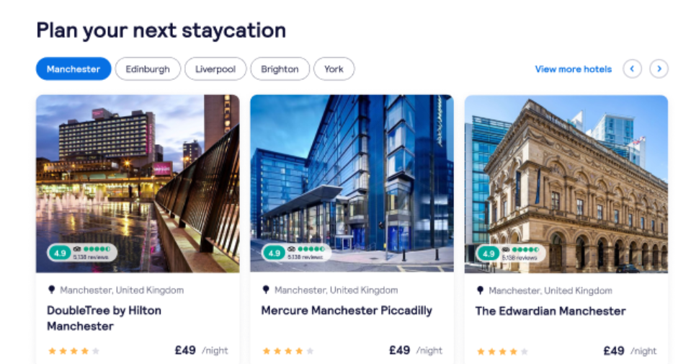

Recommended | Less Recommended
Find your place to stay  מצאו את מקום האירוח המתאים עבורכם | Find your place to stay  כדאי למצוא מקום אירוח  Or  למצוא מקום אירוח

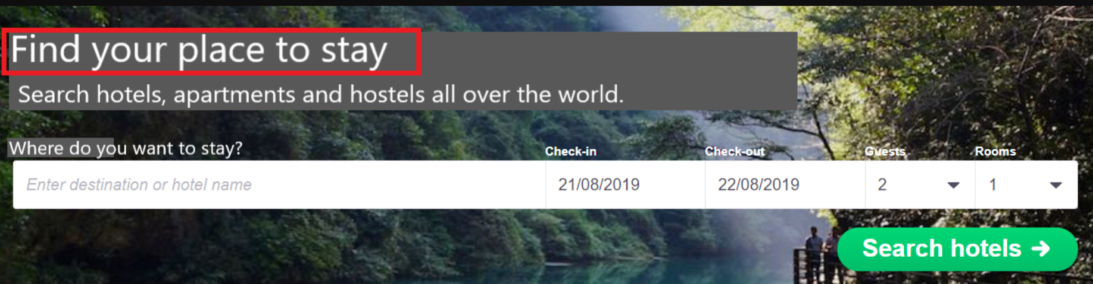

Linguistic sequence

Transliteration
Follow common local usage and official standards when transliterating place names, stations, and key travel terms. Be consistent within the language: don’t mix different transliteration systems in the same text. Do not invent new spellings or “localise” brand names – keep brand names in Latin script. If there is an established local exonym (well-known local version of a place name), use that; otherwise use the standard transliteration.
If an organisation or a company has a common Hebrew translation or transliteration, be sure to use it. If not, leave the name in English. In cases of acronyms, it’s best to translate the name in full and add the acronyms in parentheses.
Here you can find examples for all 3 cases:
The European Union => האיחוד האירופי
Google => Google
Internal Revenue Service (IRS) =>
רשות המיסים האמריקאית (IRS)

Geo-terms
Use the official or most widely used local names for countries, cities, regions and airports, and keep them consistent across all content. Avoid outdated, politically sensitive or rarely used forms, and don’t over-translate when travellers expect the original name (for example in airport names or well-known landmarks).
The most important thing is to keep the user in mind: they should be able to look up the place name easily and/or look up directions if needed. Always stick to the most commonly used and understandable version of a name.
We will use Wikipedia as a source of truth for city and country name translations. If the geo-term doesn’t have a Wikipedia page, you can use Google results as your guide (mainly relying on booking/travel sites).
If no results are found, transliterate the geo-term.
If you are uncertain about the pronunciation and therefore can’t guarantee an accurate transliteration, keep the geo-term in English.

Airport names
When translating airport names, refer to the official sources to make sure the name is correct.
If there are no results for the translation/transliteration, transliterate the airport name if possible and translate “International”:
הבין-לאומי Saint-Georges-de-l'Oyapock
Never add the word “airport” when translating an airport name to avoid duplication; it’s usually used to populate placeholders in a running copy, and the term “airport” is added to the copy when needed.
Example:
Fly from @@airport-name@@ Airport
Do | Don’t
Charles de Gaulle  שארל דה גול | Charles de Gaulle Airport  נמל התעופה שארל דה גול

Cultural sensitivity

Emojis and symbols
- Use emojis and symbols sparingly and only where they support clarity or add a light, on-brand touch.
- Make sure they are universally understood and appropriate in your market.
- Avoid replacing key words with emojis, and never use emojis in legal, policy or serious problem/incident messages.

When possible, replace any emojis or symbols present in the source copy if they are culturally inappropriate or the meaning is unclear in your market. When not possible/editable, flag the inappropriate content to Skyscanner and suggest a more suitable equivalent.

Imagery
Flag any imagery or references you encounter on Skyscanner product and other materials that could be seen as culturally inappropriate in your market (clothing, appearances, gestures, landmarks, food, family roles…)

Translation guidelines per content type

User Interface (UI)

- Be short, clear and action-focused. Prioritise clarity over playfulness.
- One idea per string; avoid ambiguity and extra words.
- Use the same wording consistently across product (e.g. always “Price Alerts”, not sometimes “Price Watch”).
Do | Don’t
Show flights / View deals  הצגת טיסות / צפייה בדילים | Let’s take a look at some awesome flights just for you!  בואו לגלות כמה טיסות מעולות שנבחרו במיוחד בשבילכם!
Trip saved  הנסיעה נשמרה | We have successfully completed the saving of your trip  השלמנו את שמירת הנסיעה שלכם בהצלחה
Something went wrong. Try again.  משהו השתבש. אפשר לנסות שוב. | Oops, that didn’t work for some mysterious reason…  אופס, זה לא עבד מסיבה כלשהי…

Marketing
There is more room for creativity for Marketing content – we want the copy to sound natural, fluid and inspirational. Avoid sticking too close to the source text and make sure the translation feels like it has been created in the target language originally.
- Use the playful, geeky, helpful Skyscanner voice, but keep promises realistic and compliant
- Focus on traveller benefits: saving time, money, effort, or discovering new places.

Do | Don’t
Explore New York for less – compare flight deals in seconds.  גלו את ניו יורק במחיר מוזל – אפשר להשוות דילים על טיסות תוך שניות. | Book the best flights to New York now.  הזמינו את הטיסות הטובות ביותר לניו יורק עכשיו.
Plan your next city break with flights, stays and car hire in one place.  לתכנן את החופשה העירונית הבאה עם טיסות, שהייה ורכב להשכרה – הכול במקום אחד. | Select origin, destination and dates to start your search.  יש לבחור מוצא, יעד ותאריכים כדי להתחיל בחיפוש.
Get ideas for your next beach escape, from nearby coasts to faraway islands.  קבלו השראה לחופשת בטן-גב מרגיעה, מחופים קרובים ועד לאיים מבודדים. | Prepare to have your mind blown by the most epic beaches on Earth!  חכו שיעוף לכם המוח כשתראו את החופים הכי מטורפים בעולם!

SEO
- Prioritise natural language, not keyword stuffing
- Write the way travellers actually search and think, while keeping our tone.
- Use clear, descriptive headings and titles
- Keep meta titles and descriptions concise and helpful

Do | Don’t
Compare cheap flights to Barcelona and find dates that fit your trip.  להשוות טיסות זולות לברצלונה ולמצוא תאריכים שמתאימים לנסיעה שלכם. | Compare cheap flights to Barcelona and find cheap dates that fit your trip.  להשוות טיסות זולות לברצלונה ולמצוא תאריכים זולים שמתאימים לנסיעה שלכם.
Weekend trips from London: find short flights and great city breaks.  טיסות לסוף השבוע מלונדון: למצוא טיסות קצרות וחופשות עירוניות מעולות. | Urban leisure experiences for time-poor consumers departing from London.  חוויות פנאי אורבניות לצרכנים קצרים בזמן שיוצאות מלונדון.
Search and compare flights to Tokyo, filter by airline, time and stops, and track prices.  לחפש ולהשוות טיסות לטוקיו, לסנן לפי חברת תעופה, שעה ועצירות, ולעקוב אחר מחירים. | The ultimate place to find unbelievable flight deals to Tokyo.  המקום האולטימטיבי למצוא דילים בלתי נתפסים על טיסות לטוקיו.

Google Ads
- Be very concise; use clear benefits and a direct call to action. There are usually strict character limits.
- Avoid clickbait and unprovable claims (no “#1”, “best”, “cheapest ever”).
- Avoid exclamation marks and other unnecessary punctuation.
- Use common search language that travellers would type.

Do | Don’t
Compare flights to Tokyo and save time.  להשוות טיסות לטוקיו ולחסוך זמן. | Get the absolute best flights to Tokyo here!  קבלו את הטיסות הטובות ביותר לטוקיו ממש כאן!
Find great flight deals to Rome  למצוא דילים מעולים על טיסות לרומא | Cheapest flights anywhere, guaranteed!  הטיסות הזולות ביותר לכל מקום, בהבטחה!

App store
- Highlight main benefits and features clearly (search, compare, track prices).
- Use simple, natural phrases that work well in screenshots and previews.
- Avoid superlatives and guarantees.

Do | Don’t
Compare flights, hotels and car hire in one place.  להשוות טיסות, מלונות ורכבים להשכרה במקום אחד. | The only travel app you’ll ever need.  אפליקציית הנסיעות היחידה שאי פעם תצטרכו.
Set price alerts and get notified when fares drop.  כדאי להגדיר התראות מחיר ונודיע לכם כשיש ירידה במחיר. | Find the best flights in the world, every time.  למצוא את הטיסות הטובות ביותר בעולם, בכל פעם.

Editorial and blog posts
- Use a warmer, more descriptive tone, but keep it factual and practical.
- Balance inspiration with concrete tips (times to go, rough prices, how to get around).
- Adapt and localise content that isn’t relevant for your market
Do | Don’t
If you’re on a budget, look for flights midweek and avoid public holidays.  אם יש לכם תקציב מוגבל, כדאי לחפש טיסות באמצע השבוע ולהימנע מנסיעות בחגים. | Only fools fly in summer – you must go in spring or not at all.  זה לא חכם לנסוע בקיץ – עדיף לטוס באביב או פשוט לוותר על הנסיעה.

Emails and push notifications
- Keep subject lines short and clear, and body copy friendly, helpful and inspirational.
- Make it obvious what the traveller can do next (search, check a deal, manage a booking).
Do | Don’t
Flight prices for Lisbon have changed  מחירי הטיסות לליסבון השתנו | You won’t believe this crazy deal!!!  לא תאמינו לדיל המטורף הזה!!!!
Prices for your London–Lisbon trip are lower. Check the latest fares and see if it’s time to book.  הייתה ירידה במחירי הטיסות שלך מלונדון לליסבון. כדאי לעיין בתעריפים העדכניים ביותר ולבדוק אם זה זמן טוב לבצע הזמנה. | Click now or miss out forever – these are the best flights you’ll ever see.  לחצו עכשיו לפני שתפספסו את הדיל – אלו הטיסות הטובות ביותר שאי פעם תראו.

Legal, Policies, Terms and Conditions

- Prioritise accuracy, clarity and consistency over tone.
- Be precise and neutral; avoid jokes, idioms and emotional language.
- Do not add promises or interpretations that are not in the source text
Do | Don’t
These terms apply to all searches and bookings made on our platform.  תנאים אלה חלים על כל החיפושים וההזמנות שמתבצעים בפלטפורמה שלנו. | These terms usually apply to most searches and bookings.  תנאים אלה בדרך כלל חלים על רוב החיפושים וההזמנות.
We do not guarantee the availability or price of any flight until your booking is confirmed.  לא נוכל להבטיח את הזמינות או המחיר של טיסה כלשהי עד לאישור ההזמנה שלכם. | We can’t always guarantee availability or price before your booking is confirmed.  לא תמיד נוכל להבטיח את הזמינות או המחיר לפני שההזמנה שלכם תאושר.

Other Skyscanner-specific guidelines

Use of Skyscanner brand
The name Skyscanner is a core part of our brand identity and must be treated consistently across all languages. It should remain recognisable, correctly spelled, and used in a way that feels natural to the local audience while still protecting the brand.
For Hebrew localization purposes, keep Skyscanner in English.
When necessary, refer to Skyscanner in the masculine form:
Skyscanner הוא מנוע לחיפוש נסיעות שעוזר לכם למצוא את ההצעות הטובות ביותר.

Feature naming
When localising feature names, focus on meaning and user clarity, not on literal translation. A good feature name should be:
- Short and easy to scan
- Clear about what the feature does
- Natural and familiar in your language
- Consistent with terminology used by other travel providers in your market
Avoid direct, word-for-word translations if they sound strange, misleading, or carry unintended meanings. Only use the English name if it is already widely known and expected in your market.
Before finalising a name, check:
- How similar features are named by local travel providers
- Whether the term is already standard or commonly understood by travellers
- Whether the name could be misinterpreted
Example:
The English term “Packages” may be misunderstood as “parcels” in some languages, while we refer to a new vertical offering package holidays including flights and a hotel.
A clearer, more natural option in your language could be “package holidays” or the local equivalent travellers recognise: חבילות נופש

The use of “Best”

Be careful with the use of “best” and superlatives in general. We are unable to claim that we can find travellers the “best prices” and “best deals” as this is an objective claim versus our competition that we would not be able to substantiate.

We can, however, use “Best” when there is a clear disclaimer explaining how "best" is measured.

Example:
Do | Don’t
This is the best price we found on our platform, according to our extensive search.  זה המחיר הטוב ביותר שמצאנו בפלטפורמה שלנו, על סמך החיפוש הנרחב שערכנו. | This is the best price for the flight.  זה המחיר הטוב ביותר עבור הטיסה הזו.

Do | Don’t
Compare flight deals to Paris and find the right option for you.  להשוות דילים על טיסות לפריז ולמצוא את האפשרות המתאימה ביותר עבורכם. | Find the best flights to Paris.  למצוא את הטיסות הטובות ביותר לפריז.

For example, we can sort our flight results by “Best” results since we have a disclaimer clearly explaining how this is measured:

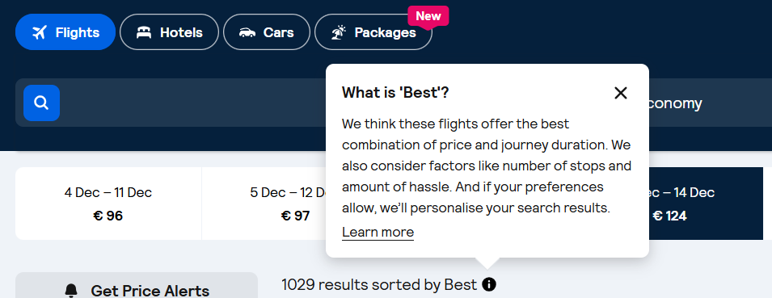

Generally, when the English copy says “best”, it’s safe to translate it the same way. When this is not the case, do not use “best” or other superlatives. Instead, use subjective claims such as “epic prices” (מחירים מעולים) or “amazing deals” (דילים מדהימים).

The use of “Discount”

Skyscanner never offer discounts to users. Any discounts come from partners (for example Trip.com), not by Skyscanner.
For this and especially for legal reasons we can therefore never imply that “we offer” (אנחנו מציעים) or “Skyscanner offers” a discount. This must be translated in a neutral way, i.e. “You are offered a discount” (אפשר ליהנות מהנחה).

Never use the translation or equivalent of “discount” (הנחה) when the English source refers to a “deal” (דיל) or “price drop” (ירידה במחיר) – these are not discounts but results of price fluctuation and it would be legally incorrect to refer to discounts.

Do | Don’t
Our Drops feature shows you flights that have dropped by at least 20%.  המאפיין Drops מציג טיסות עם ירידה במחיר של לפחות 20%. | Our Drops feature shows you flights with a discount of at least 20%.  המאפיין Drops מציג טיסות עם הנחה של לפחות 20%.

Translating sustainability-related content
When localising content about anything related to sustainability for Skyscanner, it’s essential to communicate responsibly and avoid greenwashing. Travel has an undeniable environmental impact, and our language must reflect this honestly and transparently. Use the following principles when translating or adapting sustainability-related content:
- Prefer comparatives over absolutes. Use relative statements such as “X is more sustainable than Y” (אפשרות א יותר בת-קיימא בהשוואה לאפשרות ב), rather than implying that any option is fully sustainable.
- Avoid superlatives. Do not use expressions like “the most ecological flight” (הטיסה האקולוגית ביותר) or “the greenest option” (האפשרות הירוקה ביותר), as they can overstate environmental benefits.
- Use transparent and factual language. Base all claims on clear, measurable data.
- Steer clear of vague or unregulated terms. Avoid words like ‘natural’, ‘green’, ‘non-toxic’, and ‘environmentally friendly’ (טבעי, ירוק, לא רעיל, ידידותי לסביבה), unless the statement is supported by verifiable, standardised criteria.
- Do not make unsubstantiated claims. Only reference environmental performance when data is available. Never imply that a flight or travel option is “sustainable,” “eco,” “green,” “clean,” “planet-friendly,” or “guilt-free” (בר-קיימא, אקולוגי, ירוק, נקי, ידידותי לכדור הארץ, ללא רגשות אשמה).
- Avoid reinforcing “green” imagery or symbolism. Be cautious with metaphors and word associations that might imply aviation is environmentally harmless. Overuse of green or nature-themed language can unintentionally suggest a level of sustainability that does not exist in commercial aviation today.
Do | Don’t
This flight emits 20% less carbon than a typical flight on this route  טיסה זו פולטת 20% פחות פחמן בהשוואה לטיסה טיפוסית במסלול הזה | This flight is 20% more ecological/low-emission/environmentally friendly than a typical flight on this route  טיסה זו 20% יותר אקולוגית/נמוכה מבחינת רמת הפליטות/ידידותית לסביבה בהשוואה לטיסה טיפוסית במסלול הזה
This is a sustainable flight
זו טיסה בת-קיימא
This is the most sustainable flight
זו הטיסה הכי בת-קיימא
This is a greener choice
זו בחירה ירוקה יותר/ידידותית יותר לסביבה

Accessibility guidelines

See the localised Accessibility guidelines here.
Look out for strings marked as "accessibility string / a11y" – pay extra attention to any instructions or context and follow the source when it comes to symbols and number formats (for example if the source says "10 percent discount" instead of "10% discount", the percentage should be written out also in the translations.
Avoid slashes for gender inclusivity in these strings – this is the only occasion in which you should use singular masculine when there is no inclusive option (to avoid any issues with screen readers).

Useful resources and links

The Academy of the Hebrew Language
Morfix - Online dictionary
Wellisch – Online dictionary
Avneon – Online dictionary
Academy of the Hebrew Terms - Online glossary

